Chapter 1:- Introduction

The proposed project is a smart appointment booking system that provides patients or any user an easy way of booking a doctor’s appointment online. This is a web based application that overcomes the issue of managing and booking appointments according to user’s choice or demands. The task sometimes becomes tedious and consumes time of the doctor in manually allotting appointments for the patients as per their availability. Hence this project offers an effective solution where users can view various time slots and select the preferred date and time. This system also allows patients to cancel their booking anytime. The web application is developed using HTML, CSS and Bootstrap as a front-end and PHP and MySql database as the back-end.

**Modules:**

* Admin
* User/Patient
* Doctor

Chapter 2:- System Analysis

2.1. Study of current System:

Few patients do not book their appointment in advance due to this it gets crowded in hospital/clinic and patients have to wait until their turn comes. And this causes waste of time and unwanted waiting period for patients.

Also there are some related systems available right now but no one is totally similar. Many of the system have some limitations. From the study of this similar project I got interested to develop this system.

2.2. Problem and weakness of Current System

* No user login option.
* Payment before Appointment.
* Doctors were getting many requests which they were not able to fulfil.
* Difficult for layman.
* Users could only see doctor’s location and visit-time.

2.3. Requirement analysis of New System

**Software Requirements:-**

* Operating System – Windows
* Front end – HTML, CSS, Bootstrap, Javascript
* Back end – MySql, PHP
* Server – XAMPP
* Web Browser – Google chrome, Microsoft edge, etc.

**Hardware Requirements:-**

* RAM – at least 2 GB
* Processor - 1.9 gigahertz

**Functional Requirements:-**

* + FR01: The user should be able to register and login into the system.
  + FR02: The user should be able to search doctor, book appointment, delete appointment, and download appointment slip.
  + FR03: The user can change his profile info at any time.
  + FR04: Database has to store all the information efficiently without any information loss.
  + FR05: Doctors should be able to accept/reject appointment request sent by patients.
  + FR06: Doctors should be able to schedule/update their time slots.
  + FR07: Admin should be able to accept/reject registration request sent by doctors.
  + FR08: Admin should be able to manage doctors and patients.
  + FR08: Admin should be able to view appointments of system.

**Non Functional Requirements:-**

* **Performance Requirements:** 
  + The system need to be reliable
  + If unable to process the request then appropriate error message is printed.
  + Web pages are loaded within few seconds
  + **Safety Requirements:**
* Doctors and patients must be authenticated.
  + **Security Requirements:**
* After entering the password and email the user can access his profile.

2.4. Brief Literature Review

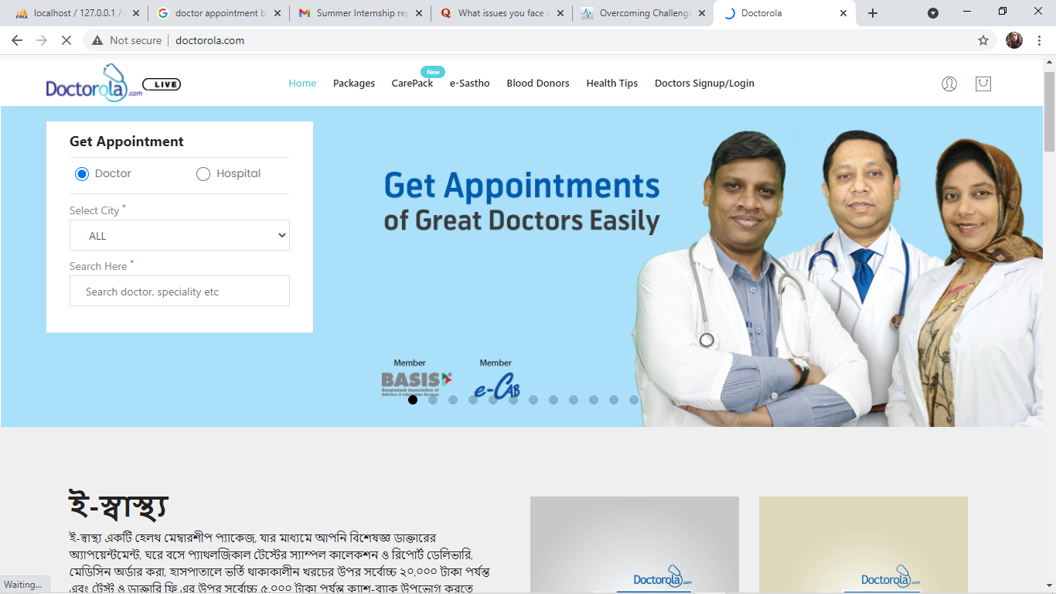

**[Fig-2.4.1: Doctorrola.com]**

http://doctorola.com/

I have explored few websites which are related to doctor appointment booking system, first my attention caught in ‘Doctorola.com’. In their system user need to search for doctor or hospital from different location and get them for booking appointment. There is no user login option and personal profile so users are totally detached from getting extra facilities in future purpose. And ‘Doctorsbd.com’ site provides only doctors list. Users can only able to know their service location from this site.

2.5. Design:  Analysis, Design Methodology and Implementation Strategy

* I have used Iterative Model for my project in which I started with some of the software specifications and develop the first version of the software. After the first version if there is a need to change the software, then a new version of the software is created with a new iteration. Every release of the Iterative Model finishes in an exact and fixed period that is called iteration.
* The Iterative Model allows the accessing earlier phases, in which the variations made respectively. The final output of the project renewed at the end of the Software Development Life Cycle (SDLC) process.
* Also testing and debugging is easy during smaller iteration and parallel development can done. Risks are identified and resolved during iteration.

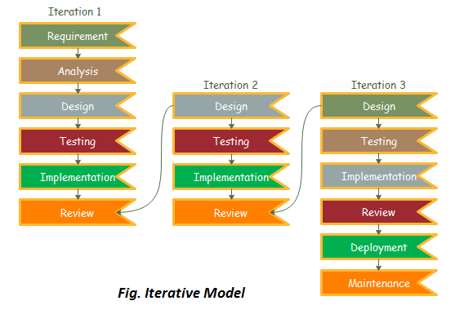

**[Fig-2.5.1: Iterative model]**

* **Planning & Requirements**: As with most any development project, the first step is go through an initial planning stage to map out the specification documents, establish software or hardware requirements, and generally prepare for the upcoming stages of the cycle.
* **Analysis & Design**: Once planning is complete, an analysis is performed to nail down the appropriate business logic, database models, and the like that will be required at this stage in the project. The design stage also occurs here, establishing any technical requirements (languages, data layers, services, etc) that will be utilized in order to meet the needs of the analysis stage.
* **Implementation**: With the planning and analysis out of the way, the actual implementation and coding process can now begin. All planning, specification, and design docs up to this point are coded and implemented into this initial iteration of the project.
* **Testing**: Once this current build iteration has been coded and implemented, the next step is to go through a series of testing procedures to identify and locate any potential bugs or issues that have have cropped up.
* **Evaluation**: Once all prior stages have been completed, it is time for a thorough evaluation of development up to this stage. This allows the entire team, as well as clients or other outside parties, to examine where the project is at, where it needs to be, what can or should change, and so on.

**Advantages of Iterative Model −**

* Some working functionality can be developed quickly and early in the life cycle.
* Results are obtained early and periodically.
* Parallel development can be planned.
* Progress can be measured.
* Less costly to change the scope/requirements.
* Risk analysis is better.
* It supports changing requirements.

**Disadvantages of the Iterative Model −**

* Each phase of an iteration is rigid with no overlaps.
* Costly system architecture or design issues may arise because not all requirements are gathered up front for the entire lifecycle.

Chapter 3: - System Modeling

3.1 Use Case Diagram:

**System boundary:**

A system boundary defines the scope of what a system will be. A system cannot have infinite functionality. So, it follows that use cases also need to have definitive limits defined. A system boundary of a use case diagram defines the limits of the system.

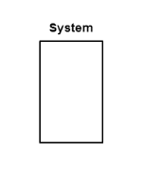

**Use case:**

Each use case is represented by an ellipse with the name of the use case written inside the ellipse, named by verb.

All the use cases are enclosed with a rectangle representing system boundary. Rectangle contains the name of the system.

It identifies, clarifies and analyzes the functional requirements of the system.

**Actor**

An actor is anything outside the system that interacts with it, named by noun.

Actors in the use case diagram are represented by using the stick person icon. An actor may be a person, machine or any external system.

In use case diagrams, actors are connected to use case by drawing a simple line connected to it. Actor triggers use case.

**Relationship:**

**Include:** When a use case is depicted as using the functionality of another use case in a diagram, this relationship between the use cases is named as an *include* relationship. Literally speaking, in an *include* relationship, a use case includes the functionality described in another use case as a part of its business process flow. An include relationship is depicted with a directed arrow having a dotted shaft.

<<include>>

**Extend:** In an *extend* relationship between two use cases, the child use case adds to the existing functionality and characteristics of the parent use case. An extend relationship is depicted with a directed arrow having a dotted shaft, similar to the include relationship. The tip of the arrowhead points to the parent use case and the child use case is connected at the base of the arrow.

<<extend>>

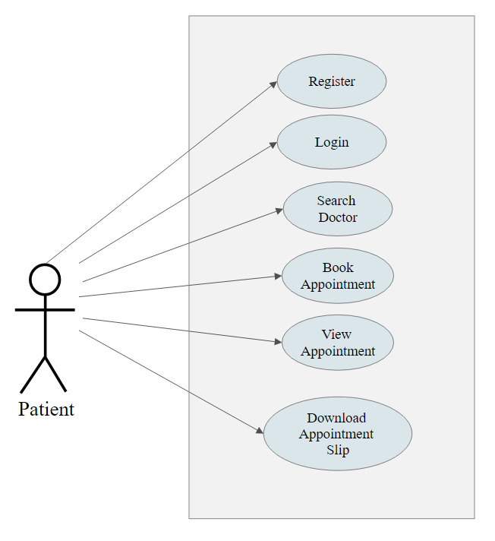

**[Fig-3.1.1: Use case Diagram- Patient]**

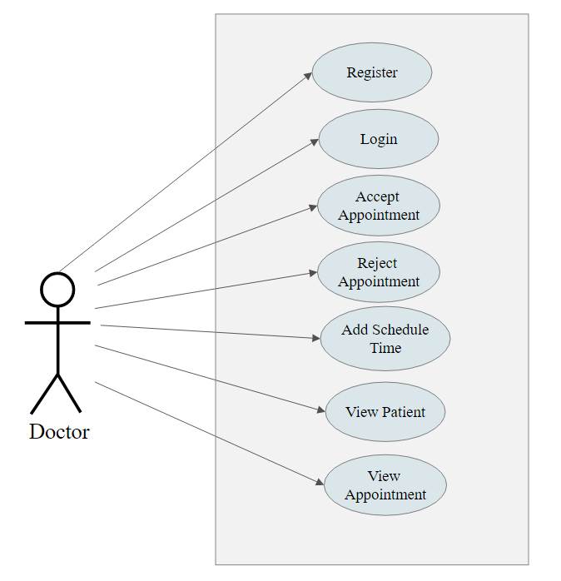

**[Fig: 3.1.2- Use case Diagram- Doctor]**

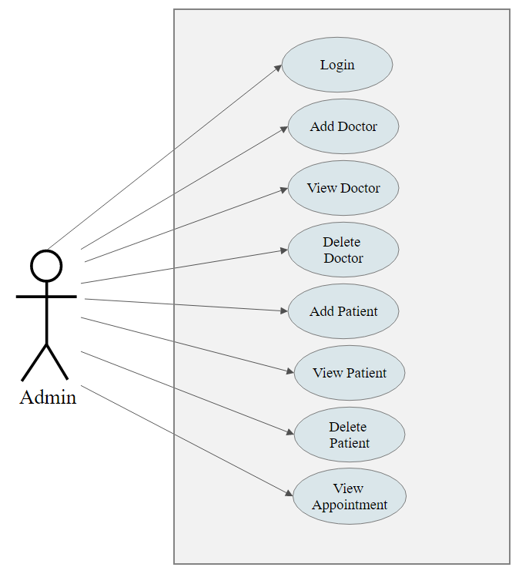

**[Fig: 3.1.3- Use case Diagram- Admin]**

3.2 Activity Diagrams

Activity diagram is used to describe dynamic aspects of the system. Activity diagram is essentially an advanced version of flow chart that modeling the flow from one activity to another activity.

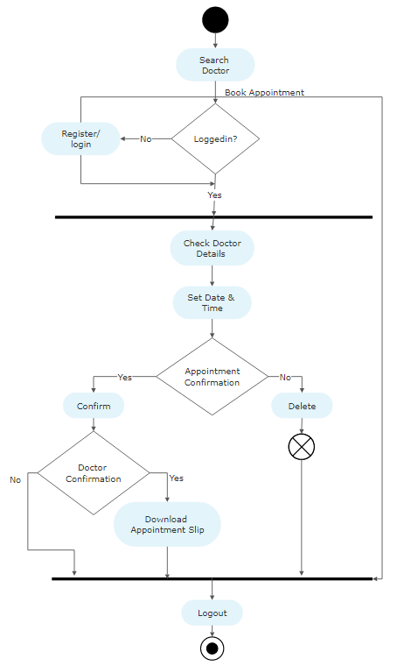

**[Fig: 3.2.1- Activity diagram of patient]**

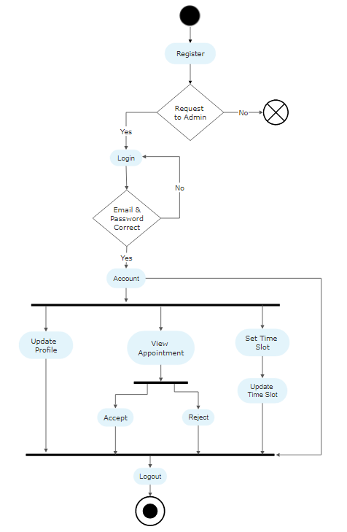

**[Fig: 3.2.2- Activity diagram of doctor.]**

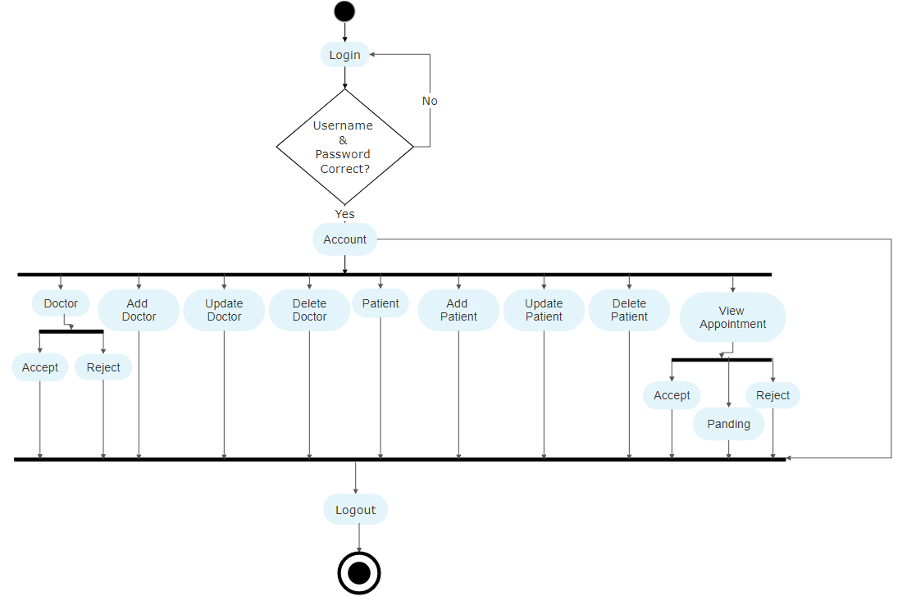

**[Fig: 3.2.3- Activity diagram of admin.]**

3.3 Sequence Diagrams

Sequence diagrams describe interactions among classes in terms of an exchange of messages over time. They're also called event diagrams. A sequence diagram is a good way to visualize and validate various runtime scenarios. These can help to predict how a system will behave and to discover responsibilities a class may need to have in the process of modeling a new system.

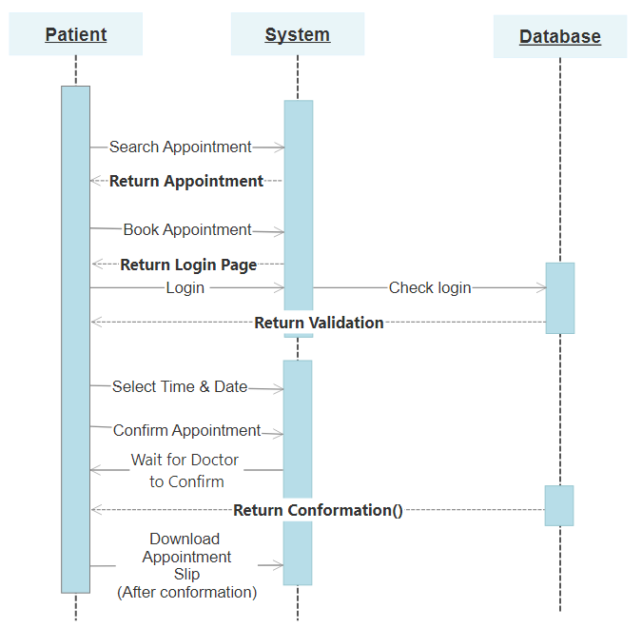

**[Fig: 3.3.1- Sequence diagram of patient.]**

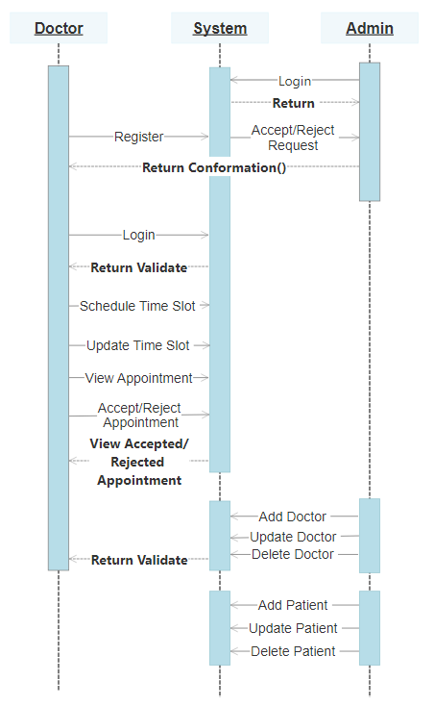

**[Fig: 3.3.2 - Sequence diagram of doctor and admin.]**

Chapter 4 – Implementation

4.1. Snapshots of project

* **Patient side snapshots**

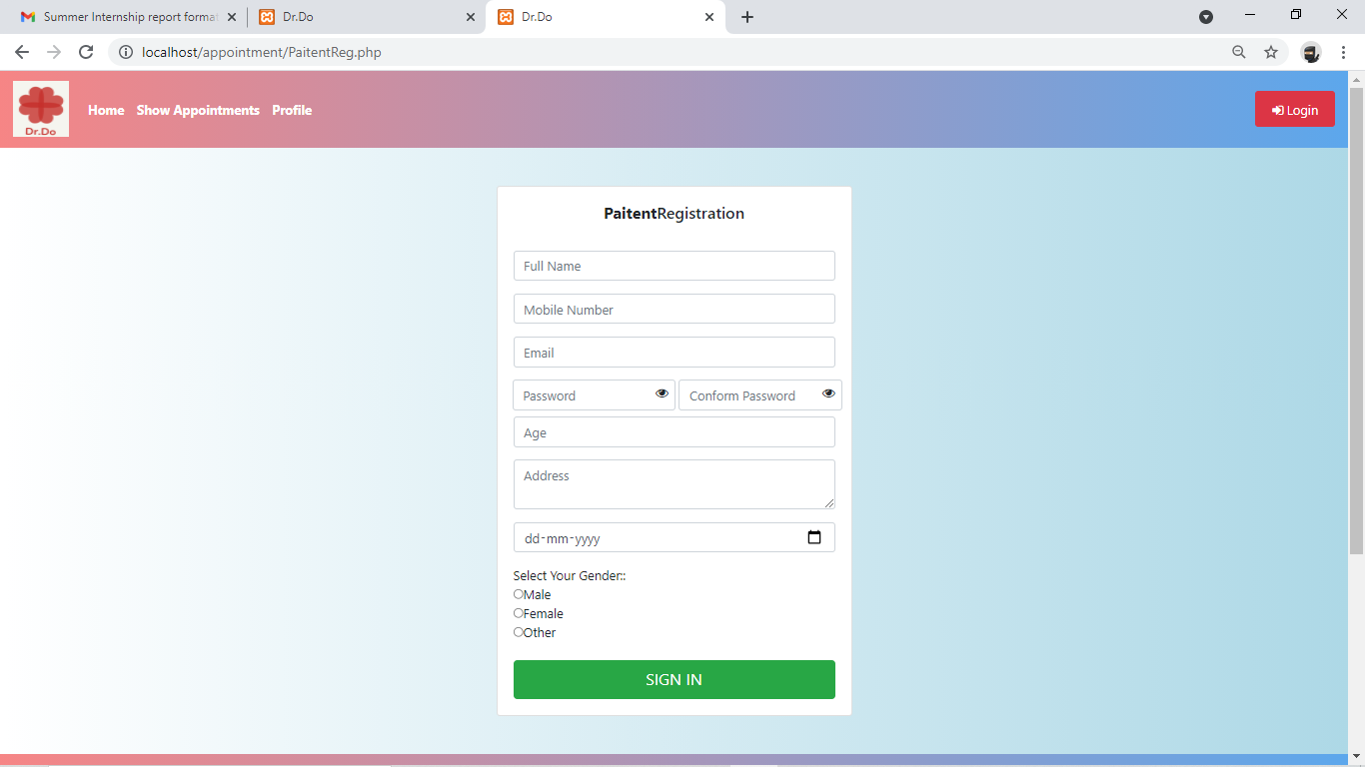

**[Fig: 4.1.1- Patient registration page.]**

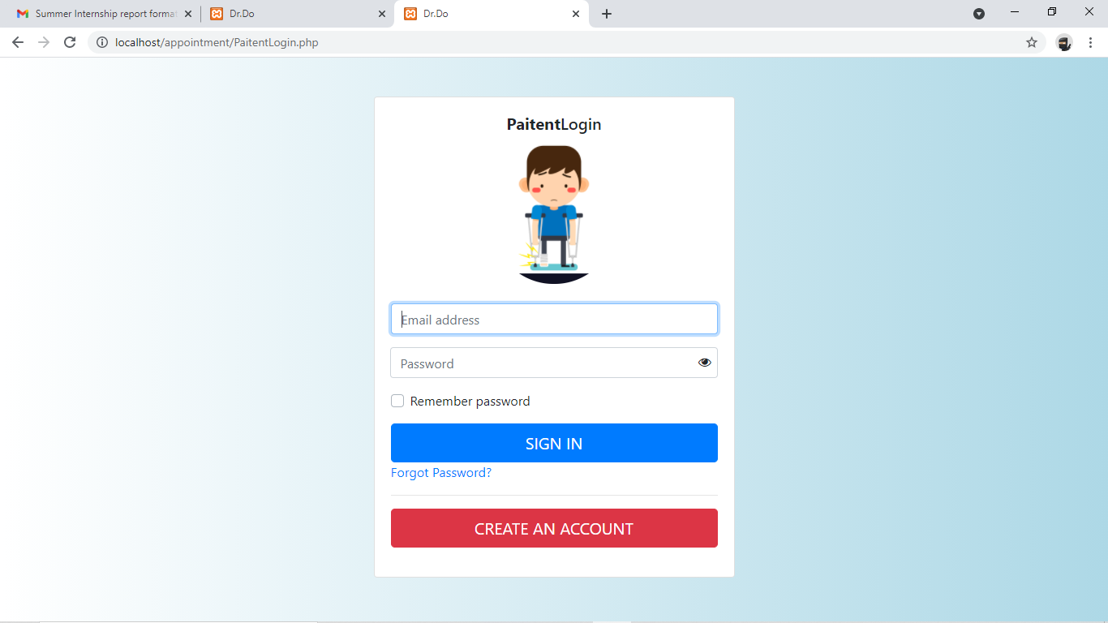

**[Fig: 4.1.2- Patient login page.]**

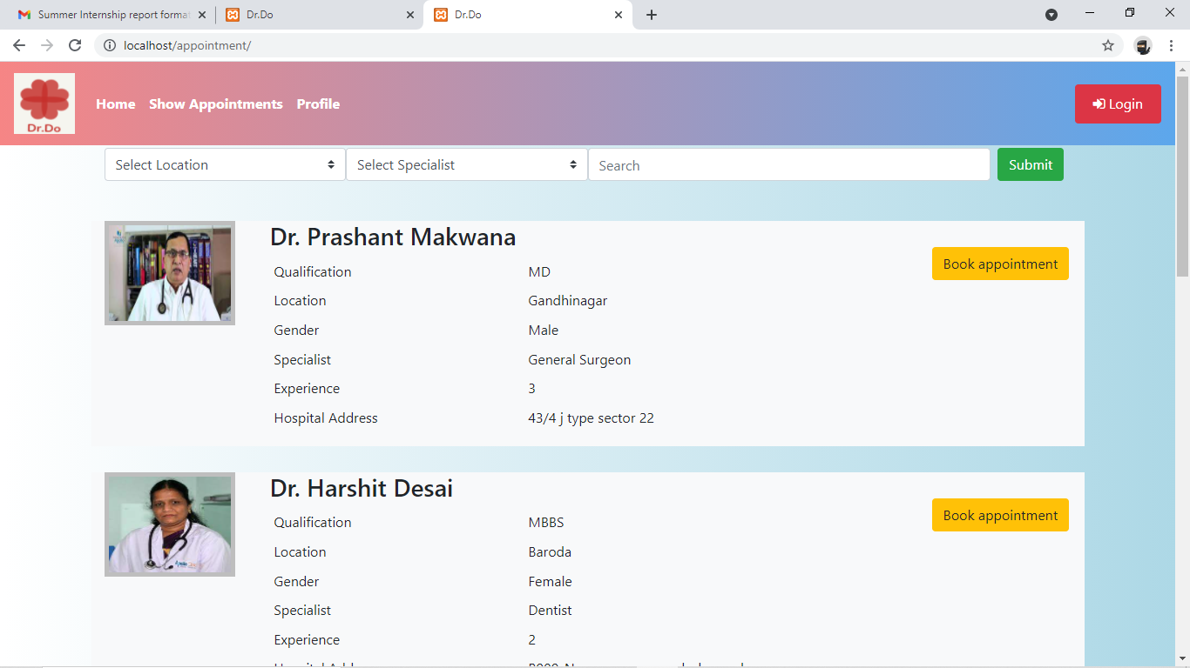

**[Fig: 4.1.3 - Patient index page.]**

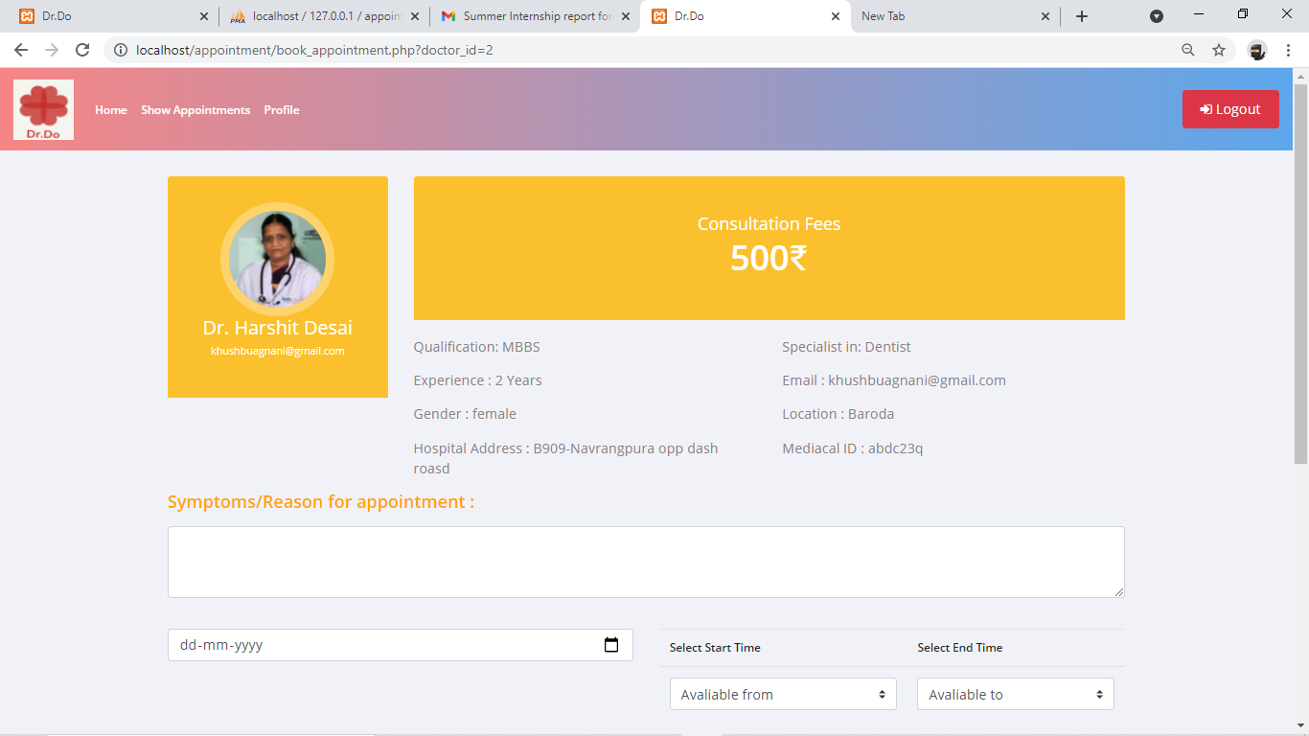

**[Fig: 4.1.4 - View doctors details.]**

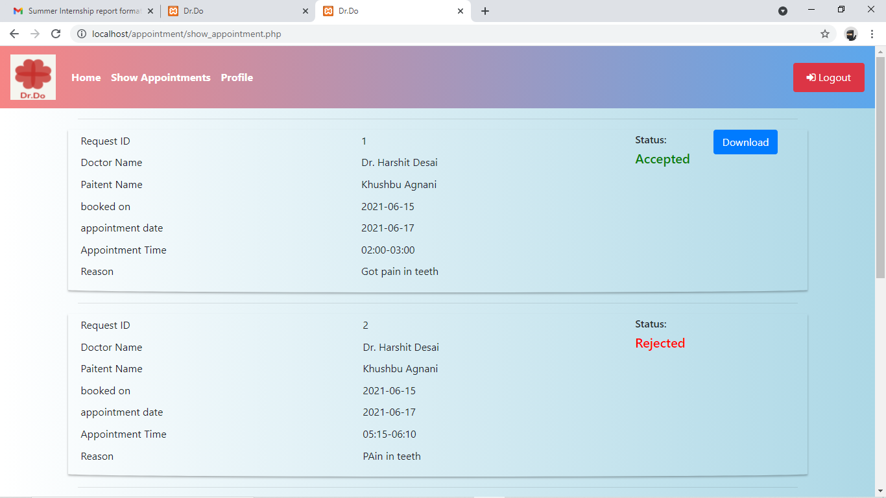

**[Fig: 4.1.5- Display booked appointments.]**

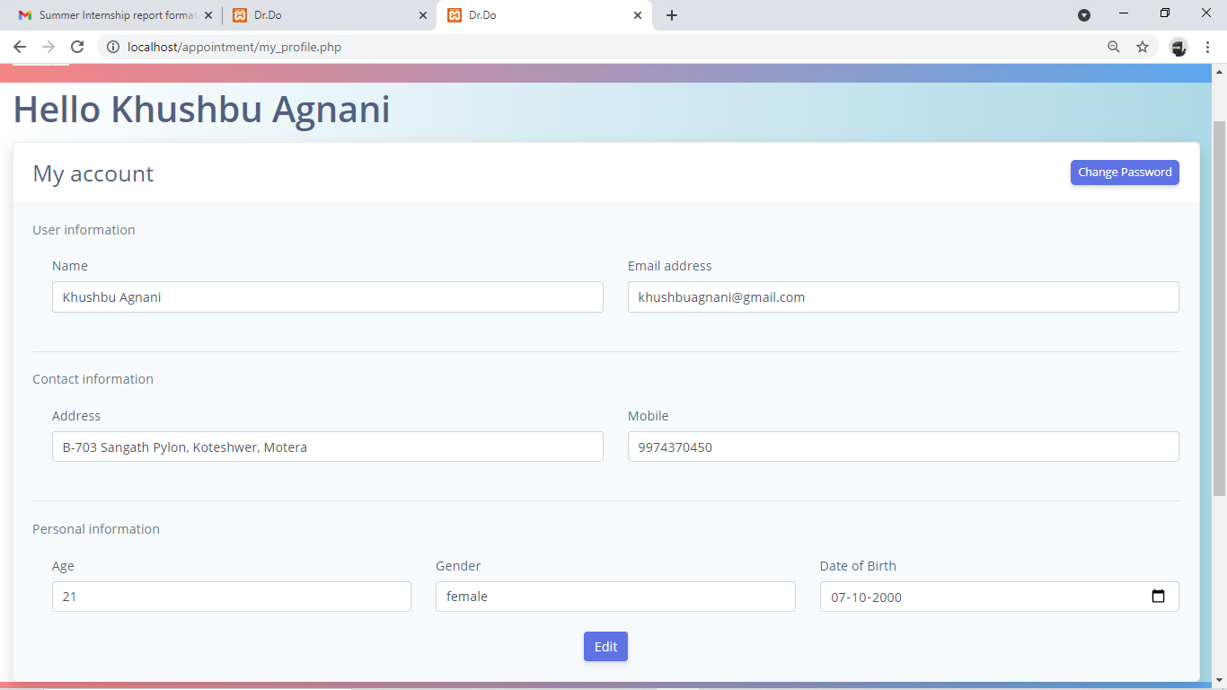

**[Fig: 4.1.6- Patients view/edit profile page.]**

## Doctor side snapshots:

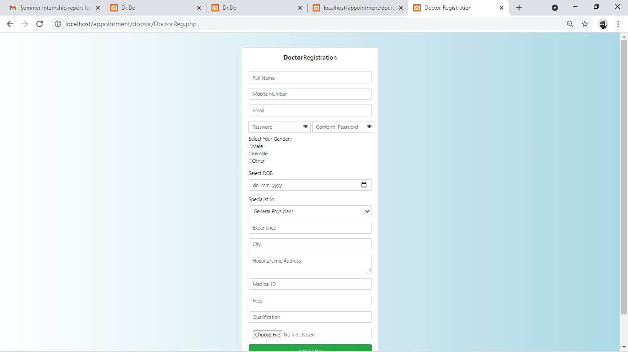

**[Fig: 4.1.7- Doctor registration page.]**

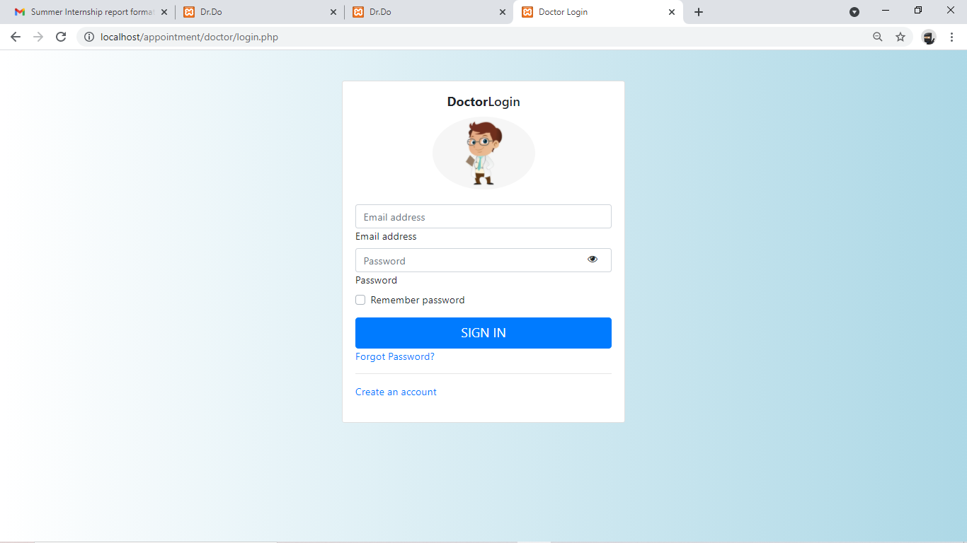

**[Fig: 4.1.8- Doctor login page.]**

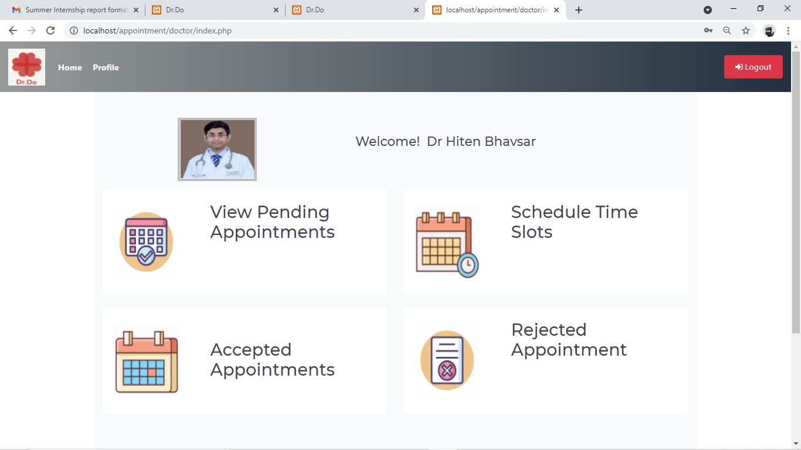

**[Fig: 4.1.9- Doctor index page.]**

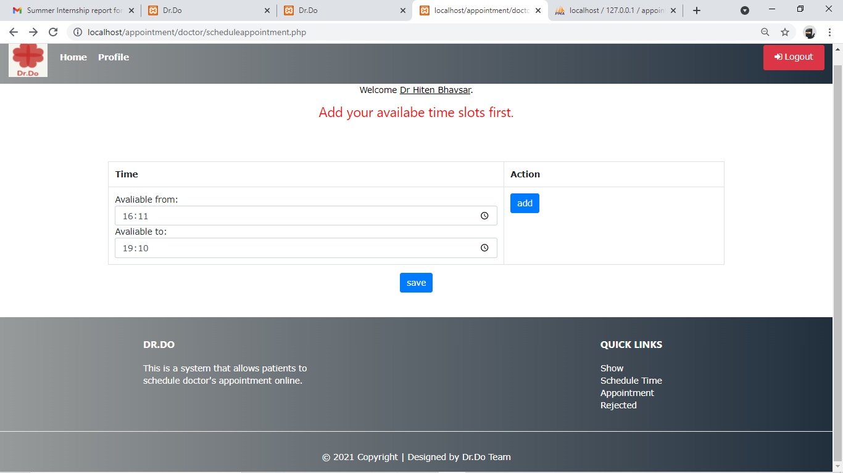

**[Fig: 4.1.10-Schedule time slot.]**

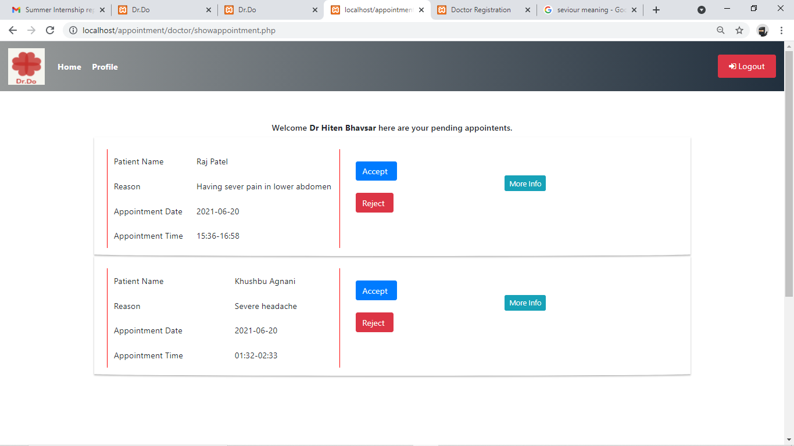

**[Fig: 4.1.11- Doctor pending appointments.]**

* **Admin side snapshots:**

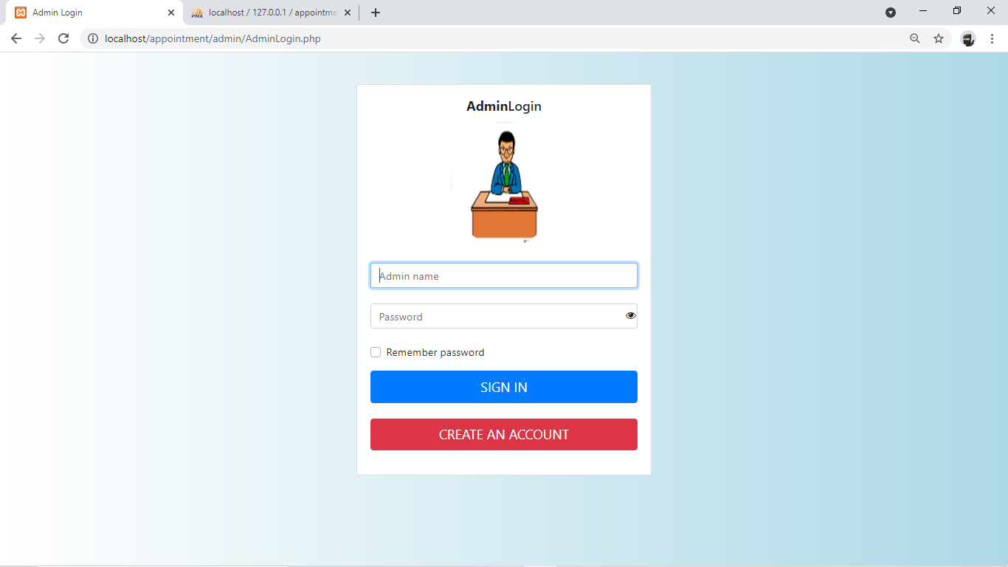

**[Fig: 4.1.12- Admin Login]**

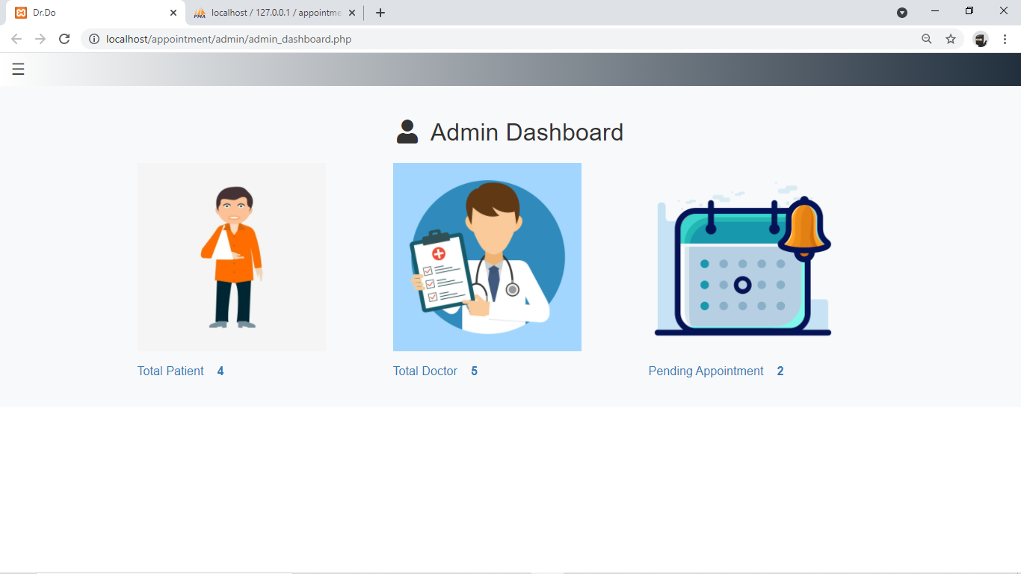

**[Fig: 4.1.13- Admin index page.]**

## 

**[Fig: 4.1.14- Side navigation bar.]**

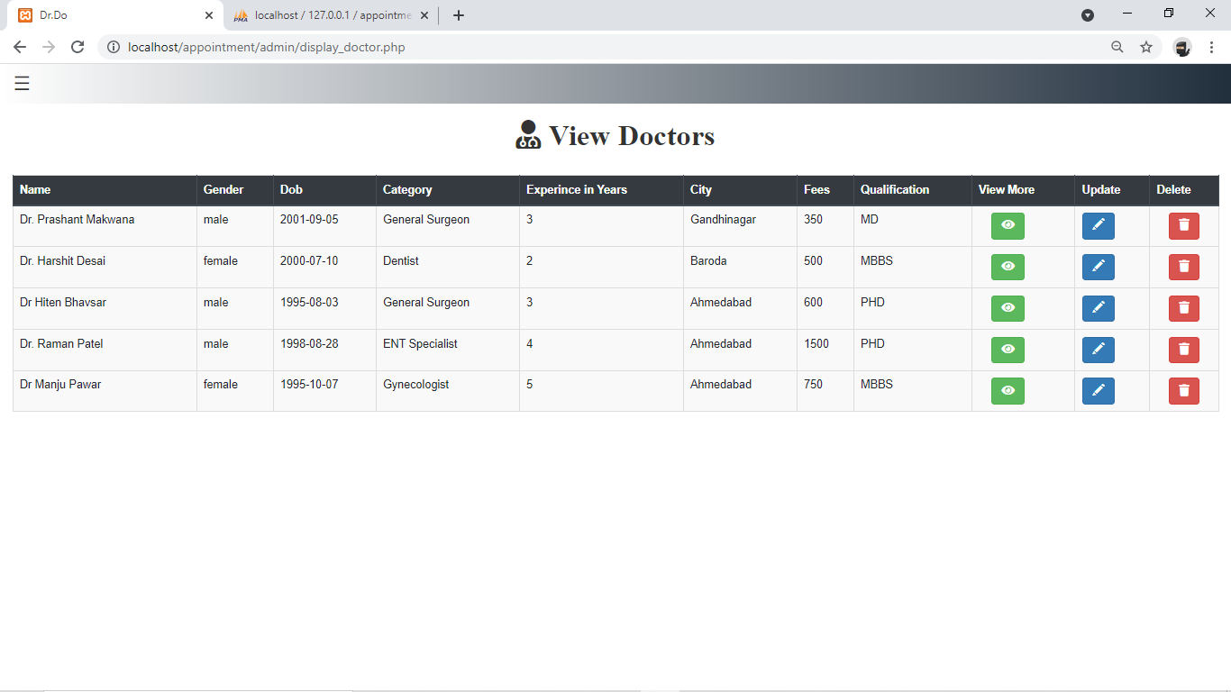

**[Fig: 4.1.15- Doctor Management page.]**

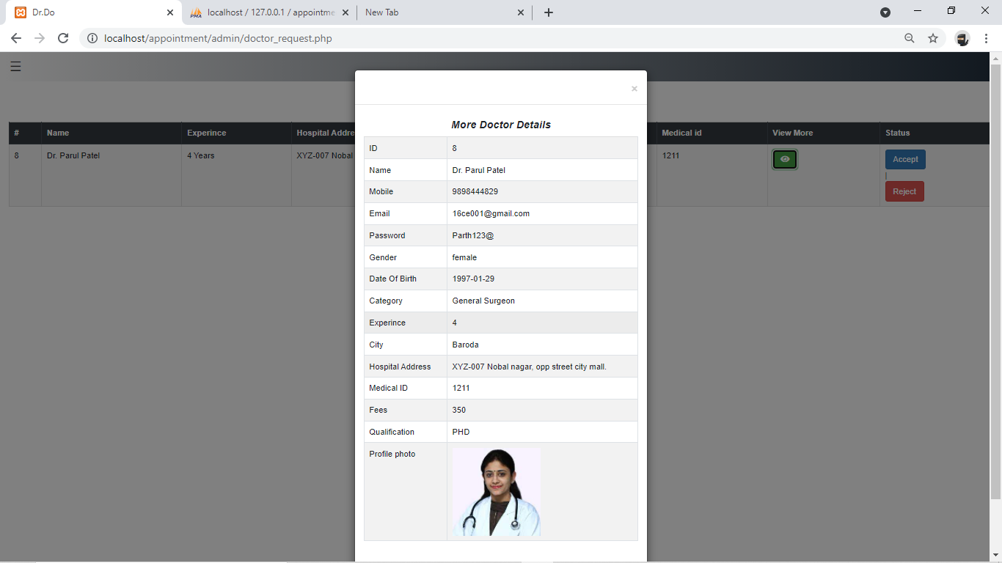

**[Fig: 4.1.16- Pending doctor requests.]**

## 4.2. Data dictionary

|  |  |  |  |  |
| --- | --- | --- | --- | --- |
| **Field Name** | **Data type** | **Field Length** | **Constraint** | **Description** |
| id | Int | 10 | Primary Key | Appointment id |
| form_patient_id | int | 10 | Not Null | Id for patient |
| to_doctor_id | int | 10 | Not Null | Id for doctor |
| booked_on | date | - | Not Null | Appointment booking date |
| appointment_date | date | - | Not Null | Appointment date |
| appointment_start | varchar | 200 | Not Null | Appointment start |
| appointment_end | varchar | 200 | Not Null | Appointment end |
| Reason | varchar | 300 | Not Null | Patient appointment reason |
| Status | varchar | 100 | Not Null | Accept or reject appointment status |

## [Table-4.1: book_appointment]

|  |  |  |  |  |
| --- | --- | --- | --- | --- |
| **Field Name** | **Data type** | **Field Length** | **Constraint** | **Description** |
| Id | int | 11 | Primary Key | Id for patient |
| Name | varchar | 200 | Not Null | Patient name |
| Mobile | big int | 30 | Not Null | Patient contact detail |
| Email | varchar | 60 | Not Null | Patient mail id |
| Password | varchar | 25 | Not Null | Login password for patient |
| Age | int | 10 | Not Null | Patient age |
| Address | varchar | 160 | Not Null | Patient living address |
| Gender | varchar | 15 | Not Null | Gender male/female |
| DOB | date | - | Not Null | Date of birth |

## [Table-4.2: patient]

|  |  |  |  |  |
| --- | --- | --- | --- | --- |
| **Field Name** | **Data type** | **Field Length** | **Constraint** | **Description** |
| Id | int | 20 | Primary Key | Unique Id for doctor |
| Name | varchar | 150 | Not Null | Doctor name |
| Mobile | big int | 15 | Not Null | Doctor contact detail |
| Email | varchar | 150 | Not Null | Doctor mail id |
| Password | varchar | 20 | Not Null | Login password for doctor |
| Gender | varchar | 15 | Not Null | Gender male/female |
| Dob | date | - | Not Null | Date of birth |
| Category | varchar | 30 | Not Null | Speciality of doctor |
| Experience | int | 10 | Not Null | Doctor medical work experience |
| City | varchar | 100 | Not Null | Location of doctor |
| hospital address | varchar | 170 | Not Null | Address of hospital in which doctor work |
| medical id | Varchar | 40 | Not Null | Doctor medical id/ license id |
| Fess | Int | 20 | Not Null | Doctor consultation fees |
| qualification | Varchar | 200 | Not Null | Doctor’s qualification |
| Photo | Varchar | 200 | Not Null | Doctor photo |
| Status | Varchar | 100 | Not Null | Accept or reject appointment status |

## [Table-4.3: doctor]

|  |  |  |  |  |
| --- | --- | --- | --- | --- |
| **Field Name** | **Data type** | **Field Length** | **Constraint** | **Description** |
| Id | Int | 10 | Primary Key | Unique ID |
| Doctore_id | Int | 20 | Not Null | Registered doctor id |
| datetimelocal | Varchar | 300 | Not Null | Start time of slots |
| Time | Varchar | 300 | Not Null | End time of slots |

**[Table-4.4: schedule appointment]**

|  |  |  |  |  |
| --- | --- | --- | --- | --- |
| **Field Name** | **Data type** | **Field Length** | **Constraint** | **Description** |
| admin_name | Varchar | 200 | Not Null | Admin name |
| admin_pwd | Varchar | 200 | Not Null | Admin password |

**[Table-4.5: admin]**

4.3. Database Relationship Diagram

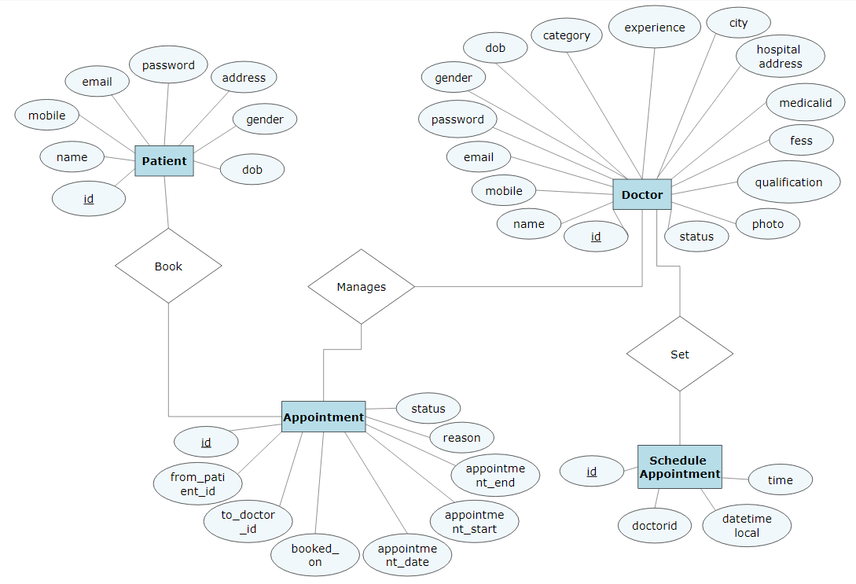

**[Fig:4.3.1- Database Relationship Diagram(ER-Diagram)]**

Conclusion:

Doctor appointment booking system is a very exciting topic to work. After going through the work, I faced many challenging tasks. Day by day healthcare system is becoming important part of our society. So I decided to build this system. This is a web based software application and it will be easily accessible from any computer/laptop by using internet. I tried to complete the software within time limit. And almost I can do it. The proposed system will easily be accessible and it will be well organized and delivered the right information in the right place.

Future scope:

* Implement Security system for project.
* Allow patient to make payment online.
* Doctors should be able to
* Add patient - doctor chatting option.
* Notify if doctor forgets to accept/reject appointment before a day or two.
* Notify patient to reschedule appointment if rejected by doctor or few days prior to next appointment’s due date.

References:

# Clean Code: A Handbook of Agile Software Craftsmanship (Robert C. Martin Series)

## PHP & MySQL Novice to Ninja – by Kevin Yank

# HTML & CSS: The Complete Reference, Fifth Edition – by Thomas A. Powell

1. <https://www.w3schools.com/php/DEFAULT.asp>
2. <https://getbootstrap.com/docs/4.0/getting-started/introduction/>
3. <https://www.tutorialspoint.com/javascript/index.htm>l